**Project Design Phase-II**

**Data Flow Diagram & User Stories**

|  |  |
| --- | --- |
| Date | 16 October 2022 |
| Team ID | PNT2022TMID29748 |
| Project Name | Project-Smart Waste Management System For Metropolitan Cities |
| Maximum Marks | 4 Marks |

**Data Flow Diagrams:**

A Data Flow Diagram (DFD) is a traditional visual representation of the information flows within a system. A neat and clear DFD can depict the right amount of the system requirement graphically. It shows how data enters and leaves the system, what changes the information, and where data is stored.

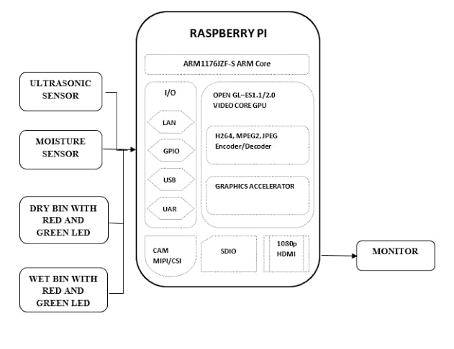

**User Stories**

Use the below template to list all the user stories for the product.

|  |  |  |  |  |  |  |
| --- | --- | --- | --- | --- | --- | --- |
| **User Type** | **Functional**  **Requirement (Epic)** | **User Story**  **Number** | **User Story / Task** | **Acceptance criteria** | **Priority** | **Release** |
| Customer  (Mobile user) | Registration | USN-1 | As a user, I can download the application | I can view the data sent by hardware | High | Sprint-3 |
| Customer (web user) | Registration | USN-1 | As a user, I can view the application web page | I can view the data sent by hardware | High | Sprint-3 |
| Customer (Data types) | Data viewing | USN-1 | As a user, I can view garbage level monitoring | Data by the hardware | High | Sprint-1 |
|  |  | USN-2 | As a user, I can view the level of wastage | Data by the hardware | High | Sprint-1 |
|  |  | USN-3 | As a user, I can view the level of dustbin is detected | Data by the hardware | High | Sprint-1 |
| Customer | Actions | USN-1 | As a user I can receive notification appears in the phone | I receive notification | Medium | Sprint-2 |
|  |  | USN-1 | As a user I need sensor Access which connected to mobile | Based on the sensor the level of the garbage will monitored | Medium | Sprint-2 |
| Administrator | Storage | USN-1 | As an administrator I can store the data | All the data are stored in cloud database | High | Sprint-4 |